**TASK-06**

**EXPLANATION:**

Write a program to print following pattern.

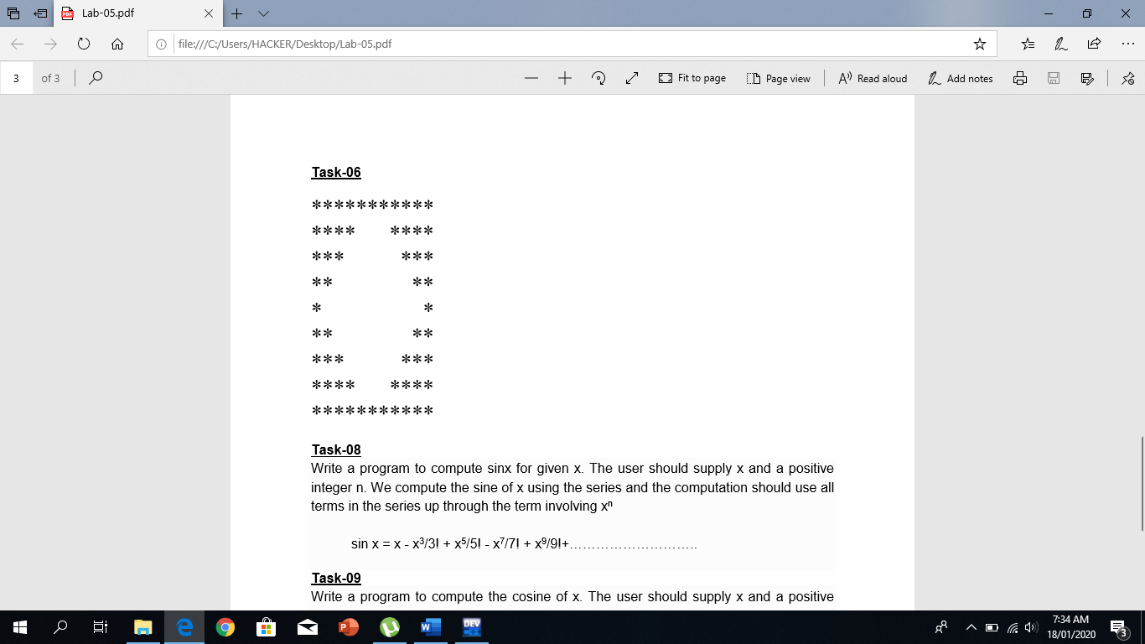

**INPUT:**

#include <iostream>

#include <string>

#include "abdullah"

using namespace std ;

int main ()

{

bool flag = true ;

while ( flag )

{

int length ;

string line = "Please enter the length or diameter of diamond (odd number) : " ;

string error = "length should not be a character or an even number!! " ;

cout << line ;

while ( ! ( cin >> length ) || length % 2 == 0 )

{

cin_clear ( line , error ) ;

}

for ( int i = 1 ; i <= length ; i++ )

cout << "*" ;

cout << endl ;

for ( int i = 1 ; i <= length / 2 ; i++ )

{

for ( int j = length / 2 ; j >= i ; j-- )

cout << "*" ;

for ( int j = 1 ; j <= ( 2 * i - 1 ) ; j++ )

cout << " " ;

for ( int j = length / 2 ; j >= i ; j-- )

cout << "*" ;

cout << endl ;

}

for ( int i = 1 ; i < length / 2 ; i++ )

{

for ( int j = 0 ; j <= i ; j++ )

cout << "*" ;

for ( int j = length - 4 ; j >= ( 2 * i - 1 ) ; j-- )

cout << " " ;

for ( int j = 0 ; j <= i ; j++ )

cout << "*" ;

cout << endl ;

}

for ( int i = 1 ; i <= length ; i++ )

cout << "*" ;

cout << endl ;

flag = continuationLoop () ;

}

}

**OUTPUT:**

